ИИН 851002402558
Тел:87753235349
КАШКИНБАЕВА Акерке Ауелхановна,
№31 Ш.Уәлиханов атындағы жалпы білім беретін мектебінің ағылшын тілі пәні мұғалімі.
Түркістан облысы, Келес ауданы

HUMAN BODY EXERCISES
Learning objectives(s) that this lesson is contributing to |  | 5.5.4.1 write with support a sequence of short sentences in a paragraph to give basic personal information.  5.4.4.1- read with some support a limited range of short fiction and non-fiction texts
Lesson objectives to: |  | - read the text and name the parts of human body  - talk about human body and answer the questions
The course of the lesson.
Planned timings | Teacher's actions |  | Pupil`s actions | Assessment | Resources
Greeting.  Organization moment.  5 min. | Good morning, dear students. I’m glad to see you.  - How are you today?  - What is the weather today?  - What date\day is it today?  In order to create friendly atmosphere in class Pupils should make a circle, touching each other with hands and say some wishes or warm words. I wish you… |  | The students greet the teacher.  Good morning, good morning to you,  We are glad to see you too.    How are you?  It is sunny/ cold/ hot.  By telling the wishes they show their appreciations.  Students of the class are listed.  -I am brave  -I am smart  -I am important | Verbal assessment | Whiteboard  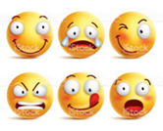  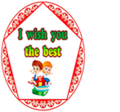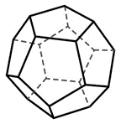
2 min | Teacher check the home task by method  "Envelope" method. |  | Students check the home task |  | 
3 min | The teacher asks to look at the Active board and press the button. The site divides the class into 2 groups.  1st group –  2nd group – |  | Students divide into 2 groups by “Fortune method”. | 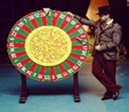 | https://ru.piliapp.com/random/wheel/
5 min | The teacher asks the students to look at the blackboard and watch a video  - What did you see in the video?  - What about this video?  - How do you think what is our theme?  The teacher sets the lesson objectives, letting students know what to anticipate from the lesson. |  | Students watch the video and answer the questions |  | https://youtu.be/RKCxrbuKNx8?si=OCoELDBWH_99aphx
Pre -reading  Main part of the lesson  5 min | Pre-reading  Teacher elicits students’ knowledge about  Human body  Task1. Work in groups. Look at the picture and answer the questions.  - What are the body parts?  - Do you like your body?  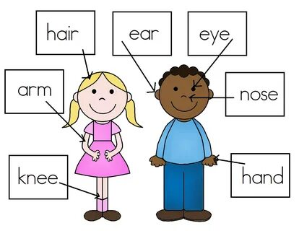 |  | Students look at the photos and try to read more as they can in 1 minute | Descriptor:  A learner  - looks at the pictures;  -answer the questions | Whiteboard  PPT
 | Teacher introduce students with new words  Eye [aɪ]көз  Arm [ɑːm] қол  Face [feɪs]бет  Teeth [tiːθ] тістер  Moustache [məsˈtɑːʃ] мұрт  Lips [lɪps] еріндер  Beard [bɪəd] сақал  Knee [niː]тізе  leg[leg]аяқ  ankle [æŋkl] тобық |  | Students write the words correctly and work with translation. | Descriptor:  A learner  -writes new words correctly | Active board
Middle of the lesson  15 min | While reading  Teacher asks students to read the text and discuss about it.  Human body  Our body is a hard system that consists of so-called “parts”. Each part of our body has its own task. We need eyes to see different articles, legs and arms-to move and do various things. Such parts of the body as head and back are particularly important for us. Brain (our head) is responsible for all our body. It controls both our physical organs and psychological state. Therefore, we should pay more attention to the health of all our body parts. To be much healthier we need to spend a lot of time on physical exercises, go in for sports and eat well-balanced food  GROUP WORK  READING AND SPEAKING  1st group –  2nd group – |  | Students work in groups, read the text and discuss about it. | Descriptor:  A learner  -work in groups  - Reads and understands the meaning of the text.  - Identifies specific information and details from the text.  - Discusses about it in  Formative assessment Teacher evaluate pupils by gold silver bronze coins  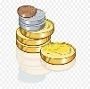  Read the title and the headings and discuss  Total: 2 point | White board  PPT
 | Teacher asks students to give them unusual task. Each student takes one cards from the first aid kid and guess the body  INDIVIDUAL WORK  SPEAKING AND WRITING  FIRST AID KID’METHOD  1. The part at the end of your arm: hand  2. The part in the middle of your arm where it bends: elbow  3. One of the two parts in your head that you see with: eye  4. The front part of your head: face  6. One of the five parts at the end of each hands: finger  7. One of the long parts of the body that is used for walking or standing: leg  8. One of the hard white things in your mouth that you use for eating: tooth  9. The front part of your body below your chest and above your legs: stomach  10. One of the two parts of a person that are used for hearing: ear |  | Students work individually, Each student takes one cards from the first aid kid and guess the body | Descriptor:  A learner  -Work individually  - takes one cards from the first aid kid  - guess the body  Guess the body.  Total: 1 point | Whiteboard  PPT  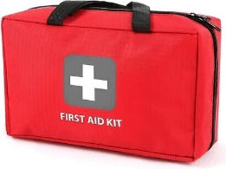
 | Teacher asks students to take one card from the pigeons and answer the questions.  INDIVIDUAL WORK  SPEAKING  PIGEONS’ METHOD  - What should you do to have a fit body?  - Do you take vitamins for a healthy body?  - Have you ever had a physical body problem?  - How do you take care of your body?  - What can you do to help your body be healthier? |  | Students work individually, takes one cards from the pigeons and answer the questions | Descriptor:  A learner  -Work individually  - takes one cards from the pigeons  - answer the questions  Answer the questions  Total; 2 point | Whiteboard  PPT  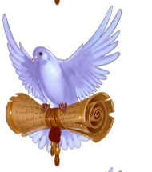
Physical training exercise –  2 min. | A break for physical activity.  Teacher plays the video with physical exercises |  | Students watch and do physical exercises. | 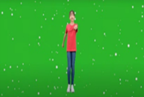 | Music  https://www.youtube.com/watch?v=ZmJEhpBFKEY
3 min | Teacher asks students to work in pairs and find hidden words in 3 minutes  Pair work  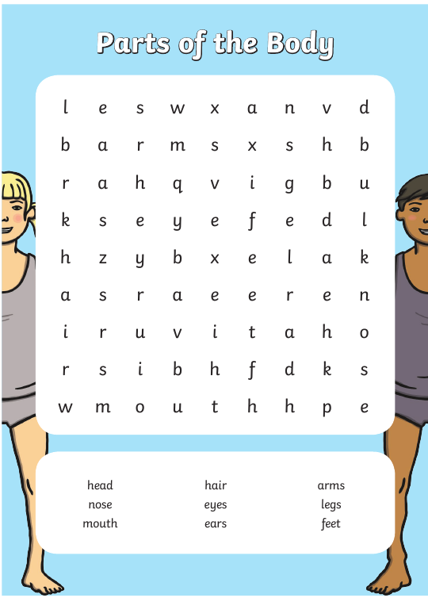 |  | Students work in pairs and find hidden words in 3 minutes | Descriptor:  A learner  -works in pairs  - find hidden words in 1 minutes  find hidden words in 3 minutes  Total: 2point | Active board  PPT  Worksheet
 | Teacher asks students to look at the active board and play an online game. They should choose correct answer looking to photos. Students play this game in groups |  | Students play online games. They press the start button and choose the correct option | Descriptor:  A learner  - Works in groups  - chooses the correct option  Chooses the correct option  Total: 1 point | Whiteboard  PPT  https://wordwall.net/resource/23771652  Extra task  https://wordwall.net/resource/34794523
 | Teacher asks pupils to work in groups and make poster about “How to keep body?” then defends it  GROUP WORK  SPEAKING  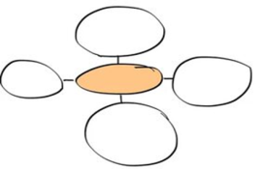 |  | Students work in groups and make poster then defends it. | Descriptor:  A learner  -works in a group  - makes poster  - defends it  Makes poster and  - defends it  Total: 3 point | Whiteboard  PPT  Poster
The end of the lesson  5 min. | Teacher gives a homework and comment the work of Sts.  Home Assignment:  Reflection  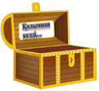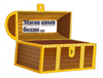   |  | Pupils write their homework for the next lesson.  Pupils. give a mark to themselves for working at the lesson.  Students think critically, exploring, developing, evaluating and making choices about their own and others’ ideas. | Pupils evaluate themselves using evaluation lists.  Reflection.  Self- Assessment. | Whiteboard  PPT

